CSC420 A4

Zhihong Wang

wangz154

1002095207

Q1. Stereo Matching Costs

(a). Imagine that two images for stereo matching are captured by the same camera but under different exposure times. Compare the two main cost functions for matching, i.e. SSD and NC, for estimating the correspondences in these two images. Which one performs better and why?

NC is better. SSD is the sum of squared differences. NC is the normalized correlation. SSD only compares the corresponding pixels, however, NC will normalize the pixels before computing the correlation. If there are two same patches, the only difference between them is the brightness. In this case, SSD will be strongly affected, since the brightness changes values of pixels. However, NC won’t be affected since the values of pixels are normalized.

Q2. Stereo Matching Implementation

Q2. (a). Write a program to compute the depth for each pixel in the given bounding box of car. Use the algorithm given in class, where given a left patch, compare it with all the patches on the right image’s scanline. To reduce computation complexity, you can try to use a small patch size, or sample patches (e.g. every other pixel) from scanline instead of comparing with all possible patches. Report what is the patch size, sampling method, and matching cost function you used. Use the parameters given and show how depth is computed for each pixel. Also visualize the depth information. Are there any outliers coming from incorrect point correspondences?

Patch size = 7

Sampling method: Scanline (every patches from left to target)

Matching cost function: NC

Yes, there are outliers. Please check the visualization for the outliers.

Read files:

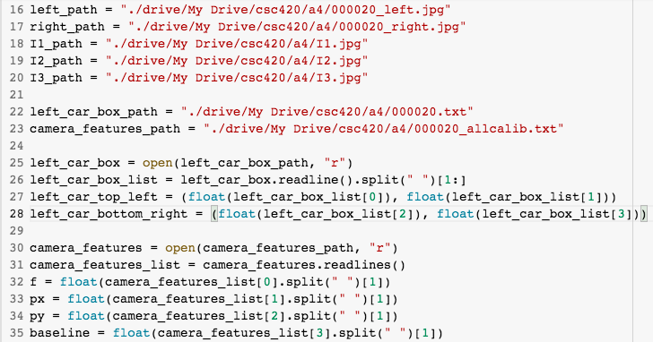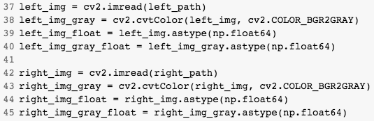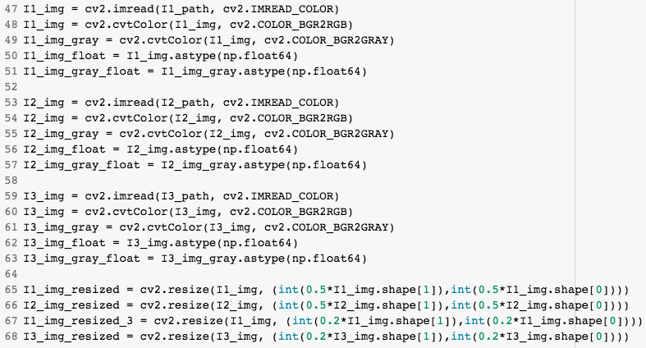

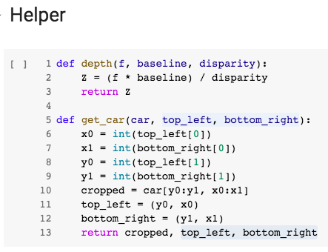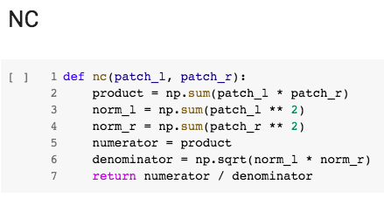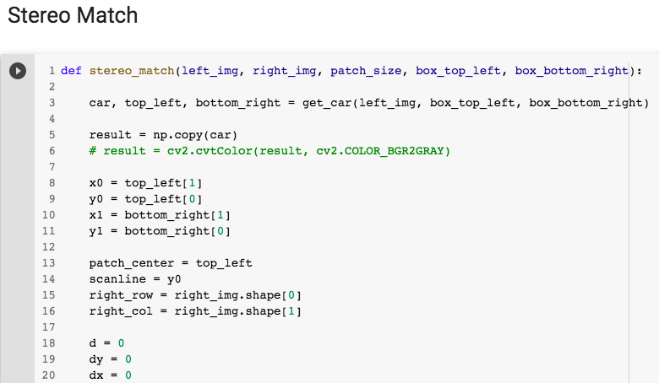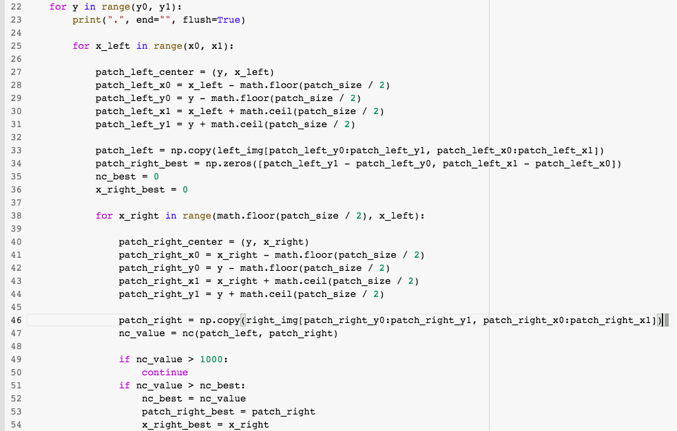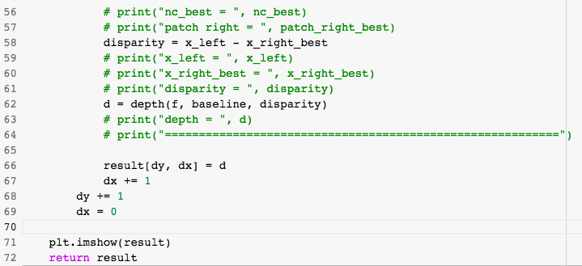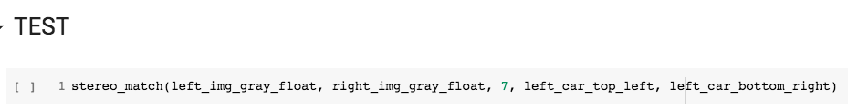

Result:

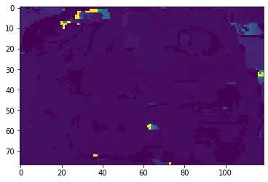

You can see there are some pixels which show clearly different colors. They are outliers from incorrect point correspondences.

Q2. (b). After you compute depth using scanline (above), go to KITTI Stereo 2015 ( http://www.cvlibs.net/datasets/kitti/eval_scene_flow.php?benchmark=stereo ), and pick a machine learning model from the scoreboard. You can pick a model that comes with code and a pre-trained model so you don’t need to implement yourself. Compute the depth for the whole image using their pretrained model. Compare your results from the previous questions with this results from this model. What is the difference, both in terms of quality and speed?

Model: GANet from KITTI Stereo 2015: <https://github.com/feihuzhang/GANet>

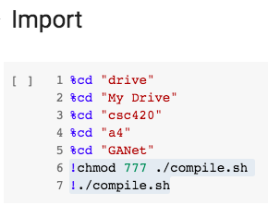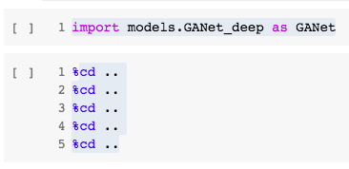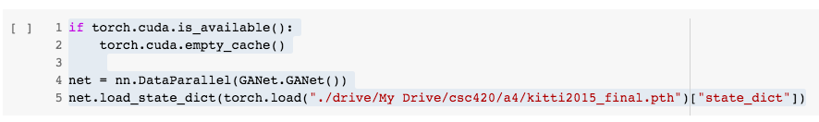

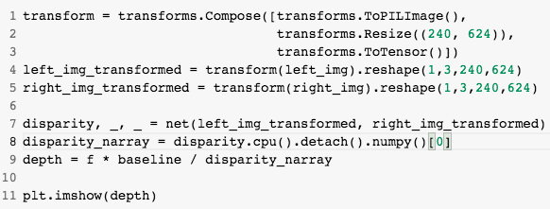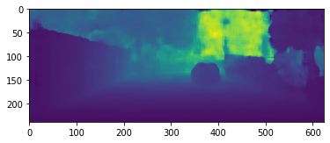

Comparing to the previous result, this is better. The quality of output is much higher, and the time-cost is much lower.

Q2. (c). Write a short summary of workflow for the model you pick, e.g. what layers do they use, what modules do they use, etc.

Layers: This model has two novel neural net layers, aimed at capturing local and the whole-image cost dependencies respectively. First, the Semi-Global Aggregation (SGA) Layer. This is a differentiable semi-global matching (SGM) over the whole image. Second, the Local Guided Aggregation (LGA) Layer. This follows a traditional cost filtering strategy to refine thin structures and edges. It learns guided filtering and recovers the loss of accuracy in down-sampling.

Workflow: The inputs (i.e. left and right images) are fed to a weight-sharing feature extraction pipeline. It consists of a stacked hourglass CNN and is connected by concatenations. The extracted left and right image features are then used to form a 4D cost volume, which is fed into a cost aggregation block for regularization, refinement and disparity regression. The guidance subnet (green) generates the weight matrices for the guided cost aggregations (SGA and LGA). SGA layers semi-globally aggregate the cost volume in four directions. The LGA layer is used before the disparity regression and locally refines the 4D cost volume for several times.

Modules: PyTorch, Numpy, math, skimage, PIL, etc.

Q2. (d). Using the depth information from models, try to determine within the bounding box, which pixel belong to the car based on its distance to the box center pixel’s 3D location (use a threshold). After that, try to determine a 3D bounding box for the car (min & max along X, Y, Z). Visualize the segmentation of pixels within the 2D box, and on another image visualize the 3D box. State the classification threshold for distance.

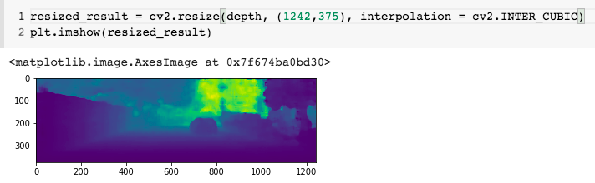

2D Box Segmentation:

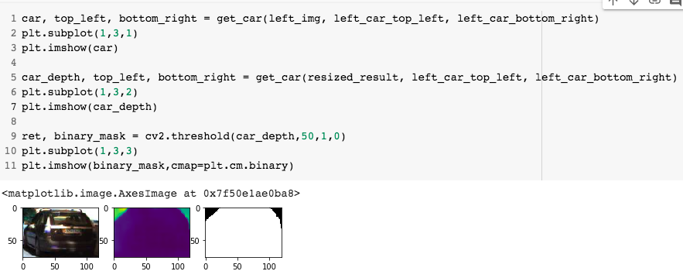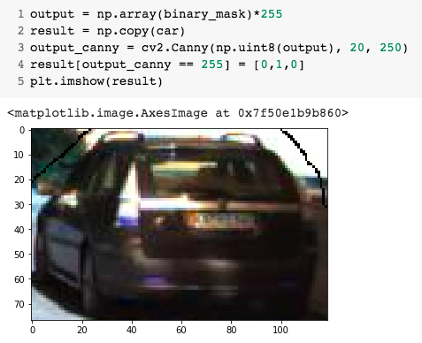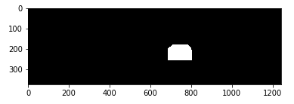

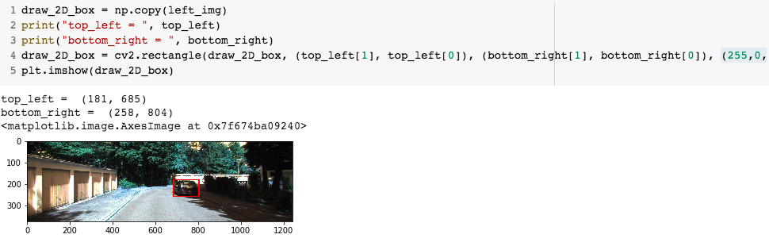

3D Box:

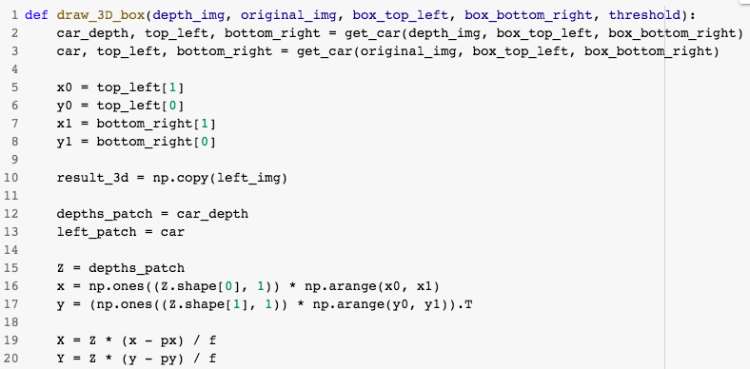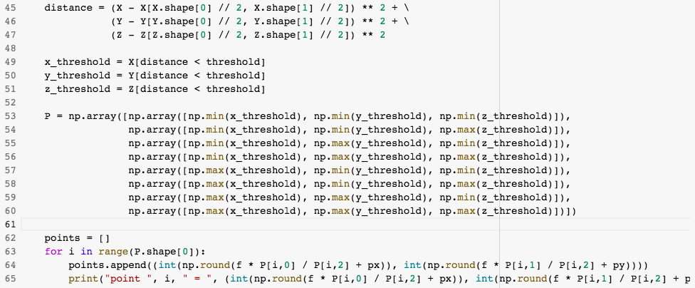

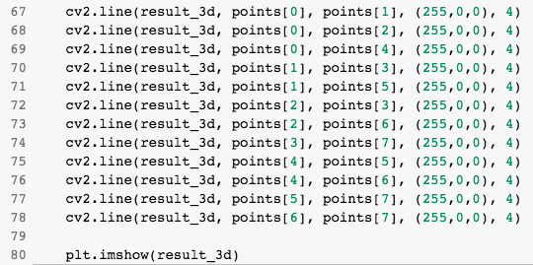

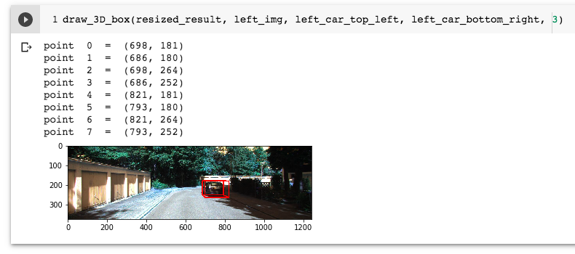

Q3. Fundamental Matrix - for this question, take 3 images (I1, I2, I3) of an object or a stationary scene as follows: Images I1 , I2 from almost the same viewpoint, but with a (roll) rotation. That is, take an image (I1), don’t move, but rotate the camera in place around 30-45 degrees, and take another image (I2). Take the third image (I3) from a different viewpoint, e.g. move the camera~20 cm to the right and rotate (out of plane) to point the camera towards the object again.

Q3. (a).

Use SIFT matching (or any other point matching technique) to find a number of point correspondences in the (I1, I2) image pair and in the (I1, I3) image pair. Visualize the results. If there are any outliers, either manually remove them or increase the matching threshold so no outliers remain. Pick 8 point correspondences from the remaining set for each image pair, i.e. (I1, I2) and (I1, I3). Visualize those 8 point matches. It helps in the later steps if the 8 point matches are somewhat distributed over the images rather than being clustered in a small region.

Distribute points:

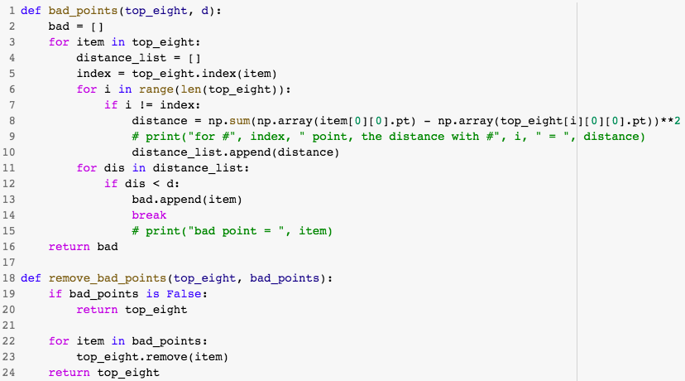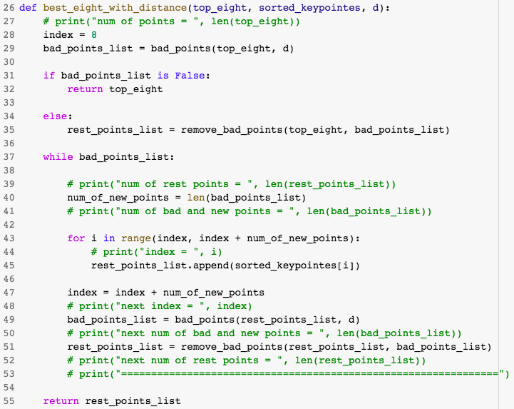

SIFT:

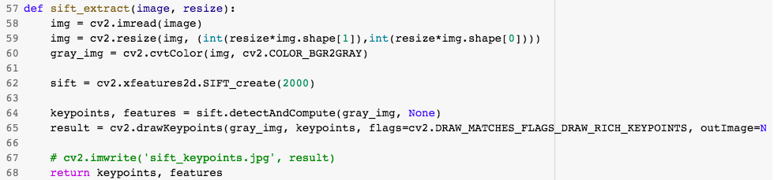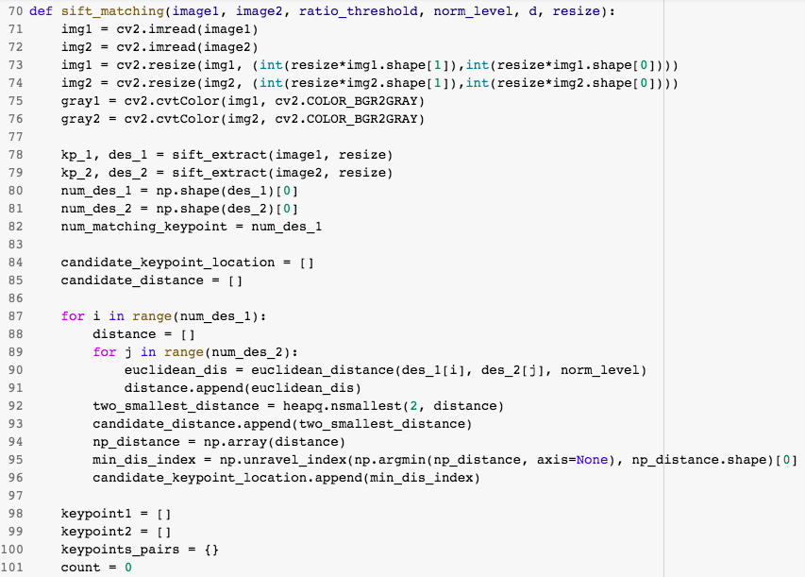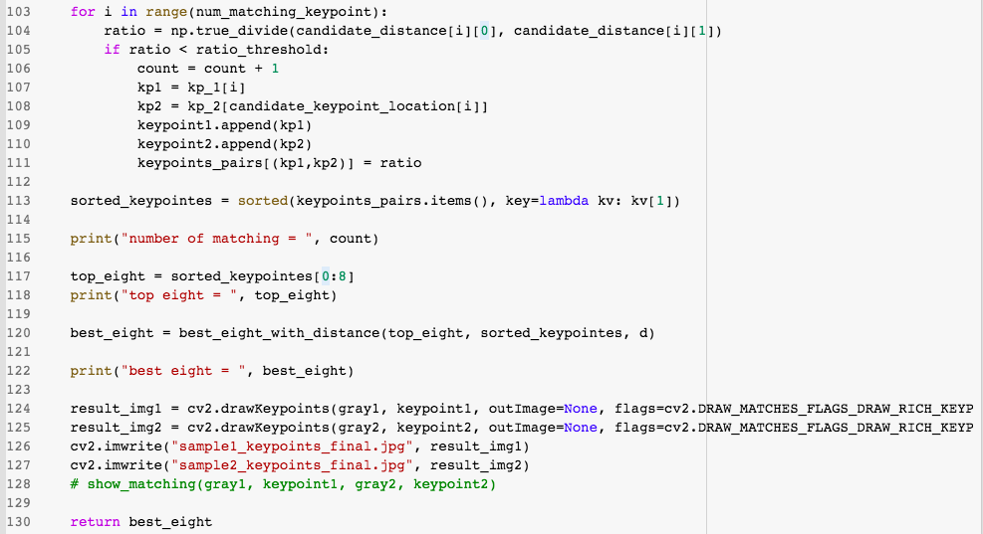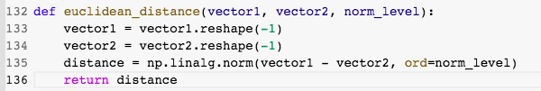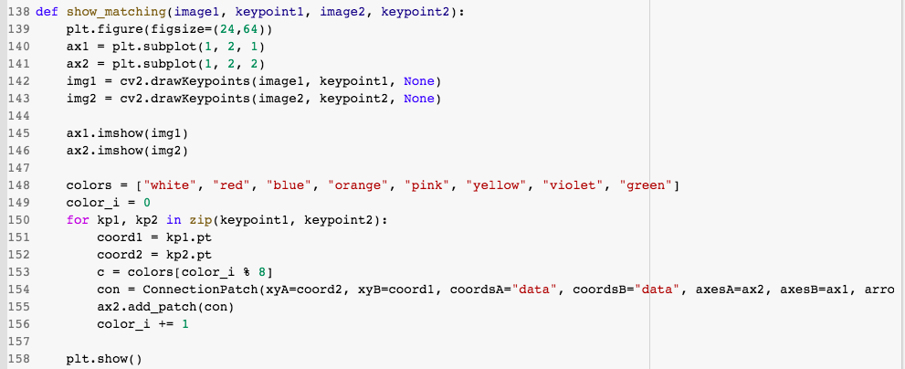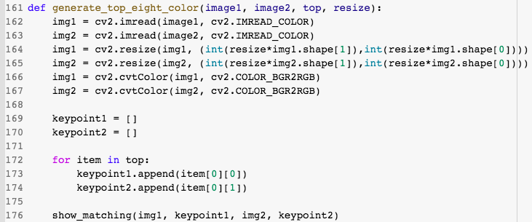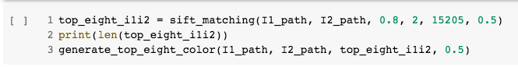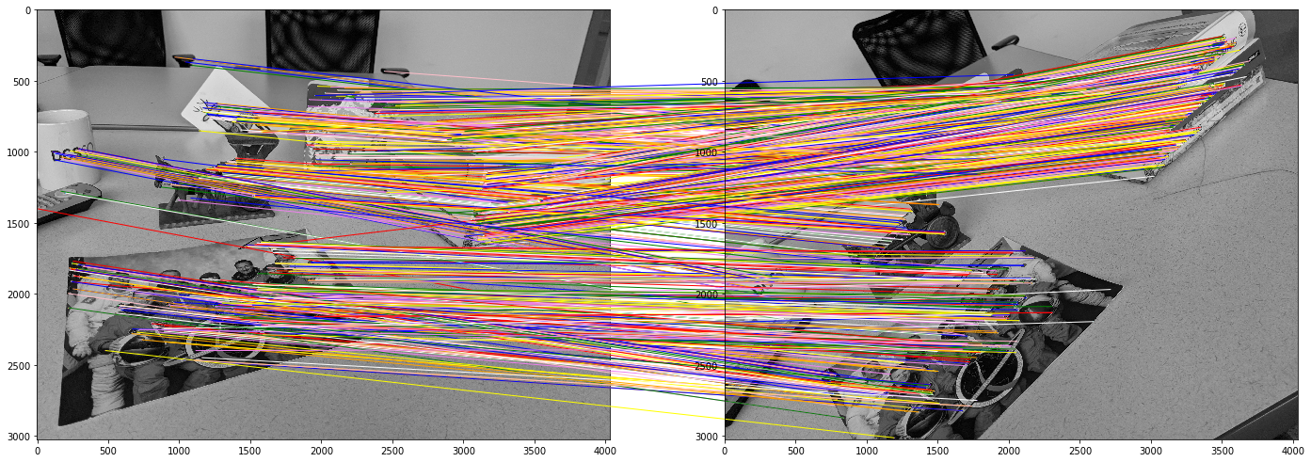

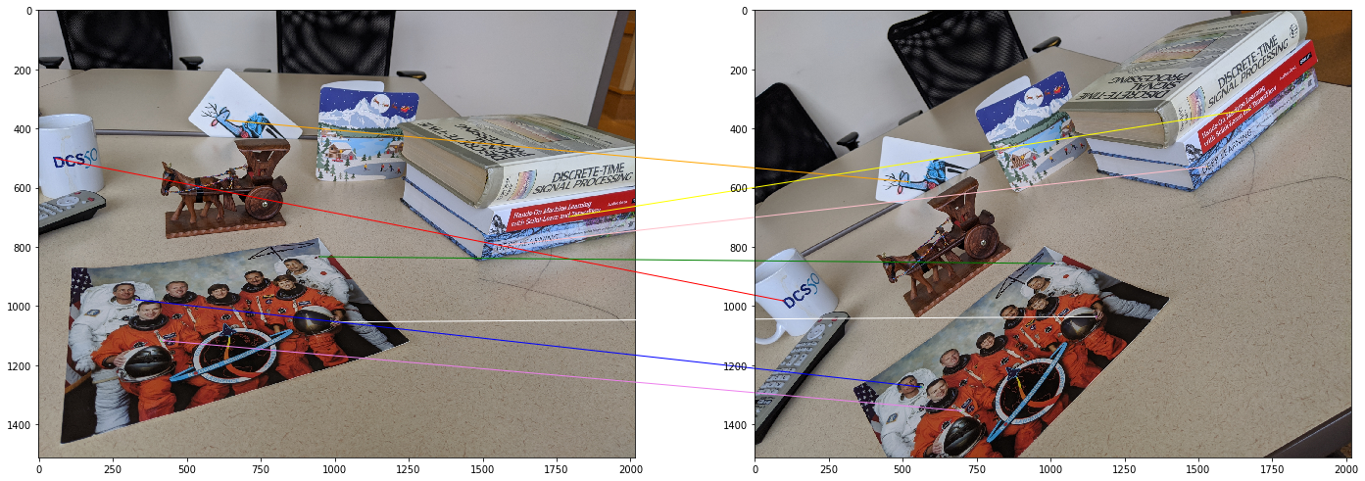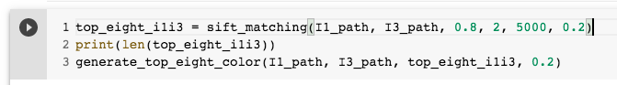

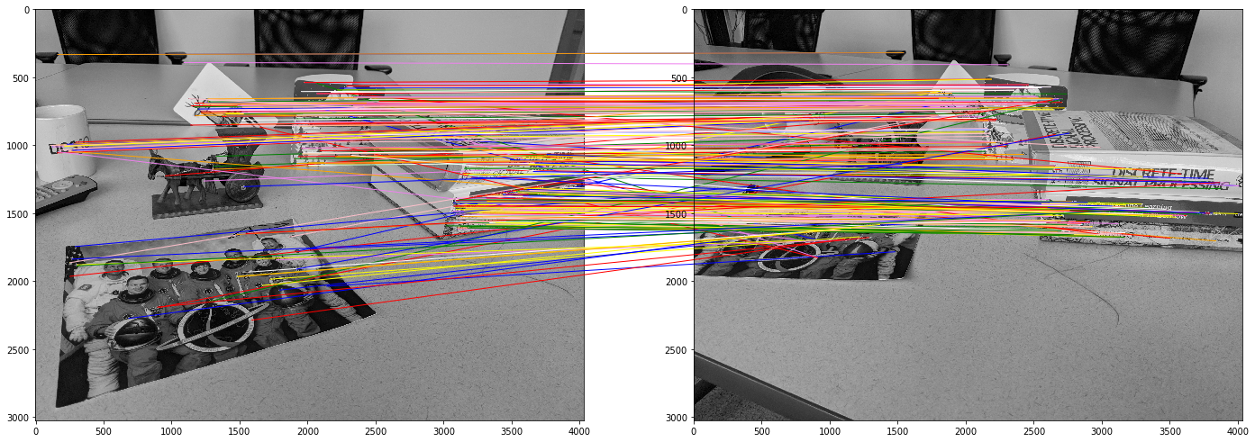

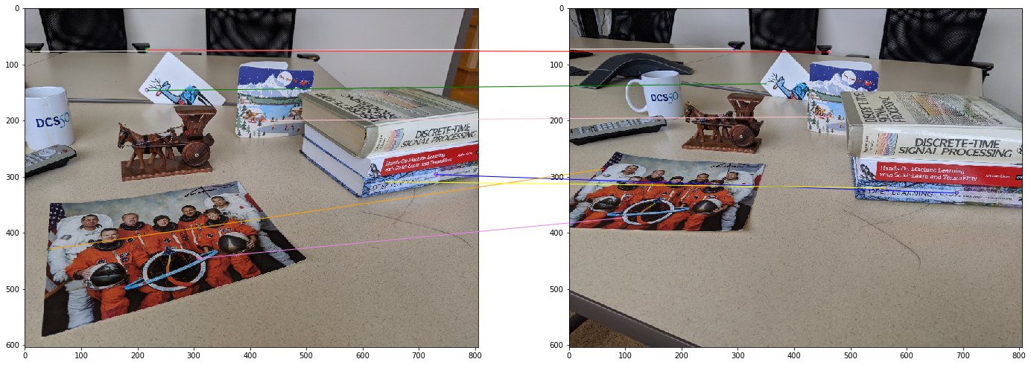

Q3. (b).

Using what we have learned in class (standard 8-point algorithm) calculate the fundamental matrix F12 for image pair (I1, I2) and Fundamental matrix F13 for image pair (I1, I3). (for this question, implement your own standard 8-point algorithm)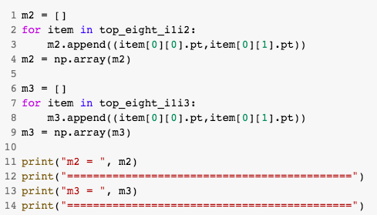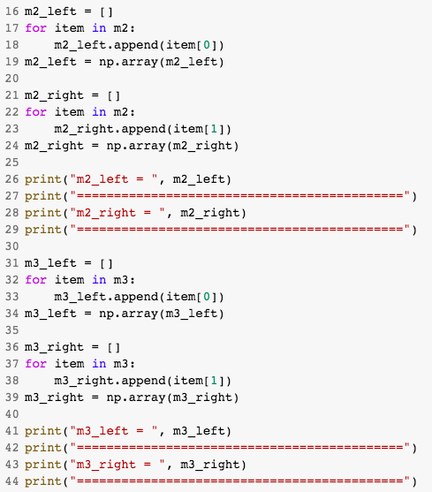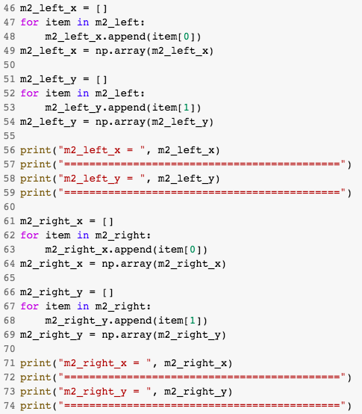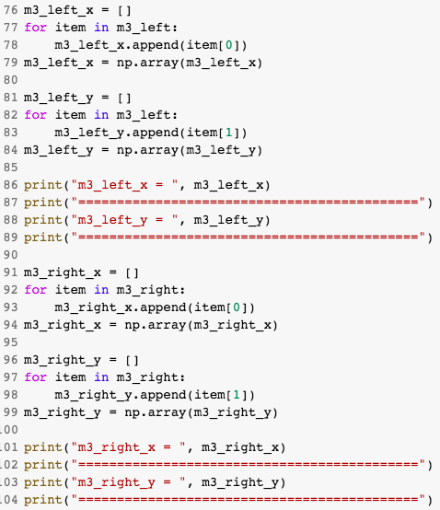

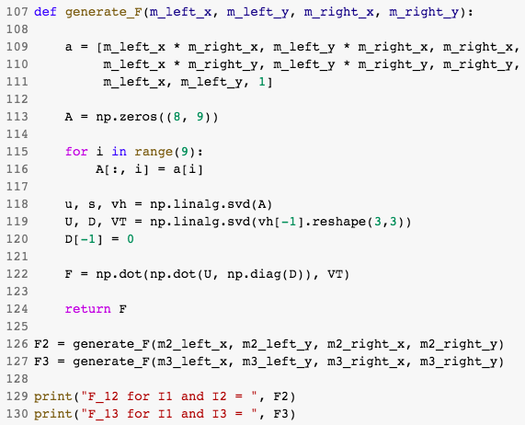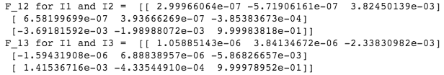

Q3. (c).

Using F12, calculate the epipolar lines in the right image for each of the 8 points in the left image and plot them on the right image. (for this question you can use any OpenCV functions you want)

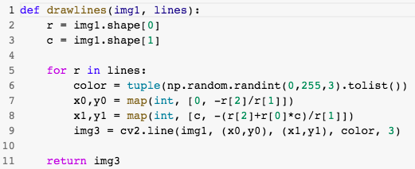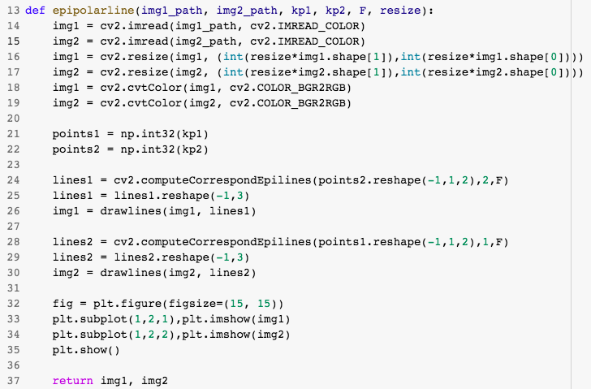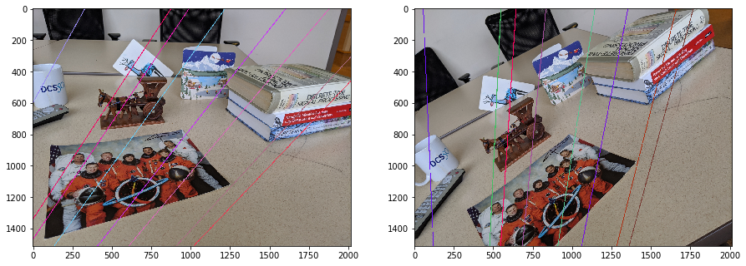

Q3. (d).

Using F12, rectify I2 with I1 and visualize the resulting image side by side with I1. Do the same for I3 using F13. (for this question you can use any OpenCV functions you want)

Resize:

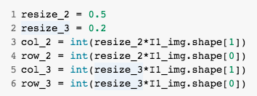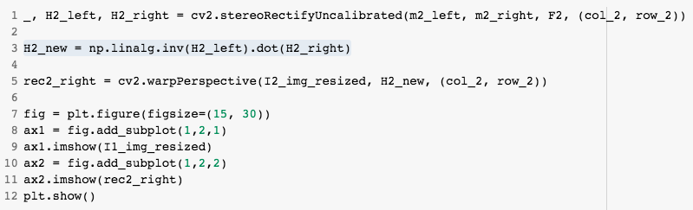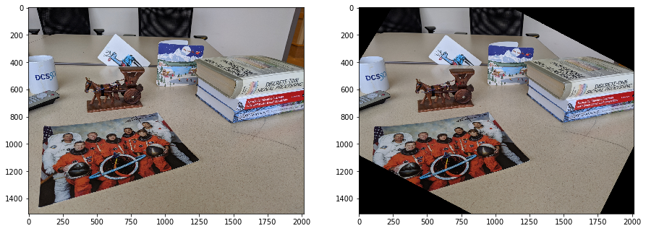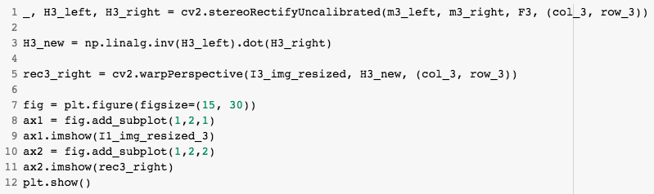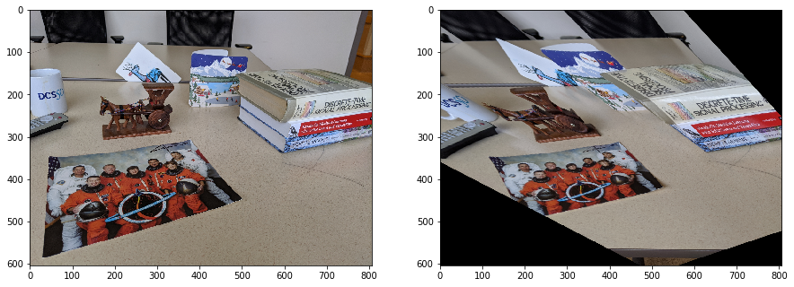

Q3. (e).

Using OpenCV, compute F’12 and F’13 and compare with your results. I.e. Are they the same? Are they similar? Briefly discuss.

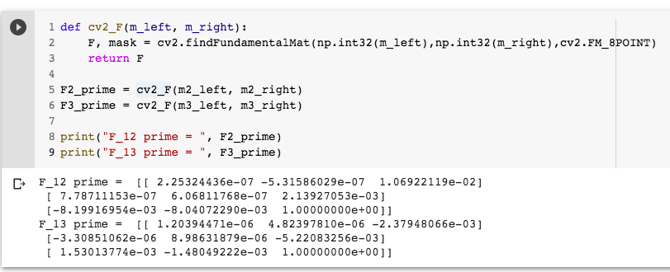

Compare with my F12 and F13 before:

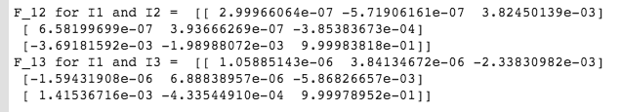

They are not the same.

Because my F generator function calculates the fundamental matrix by following the lecture slides and notes. The results of cv2 are slightly better than mine since the OpenCV performs automatically normalization and optimization.

e.g. my F (two images at the first row) VS F from cv2 (two images at the second row)

(i.e. comparing the epipolar lines)

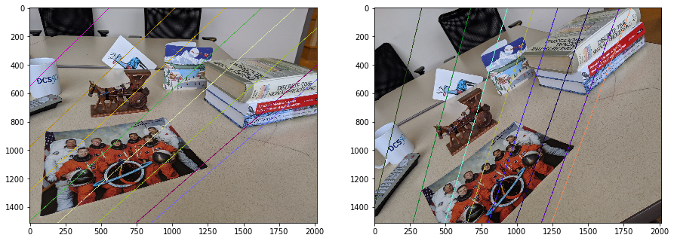

Q3. (f).

Using OpenCV, rectify the images using F’12 and F’13 and compare with your rectifications (part d). Discuss any differences.

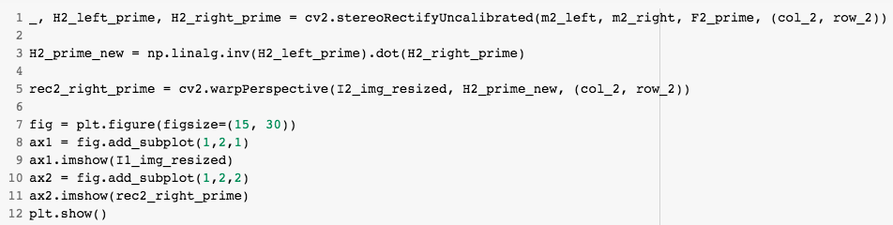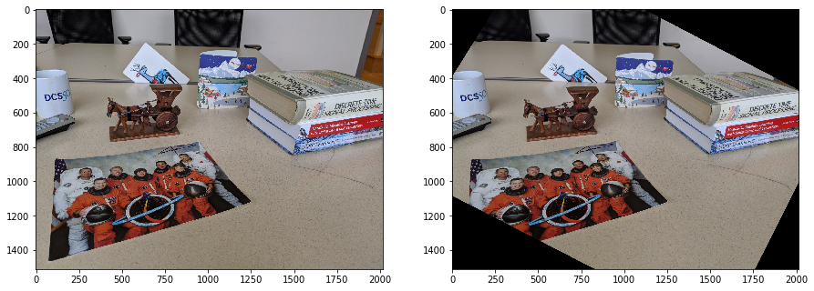

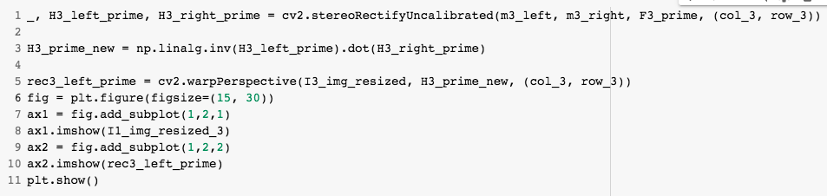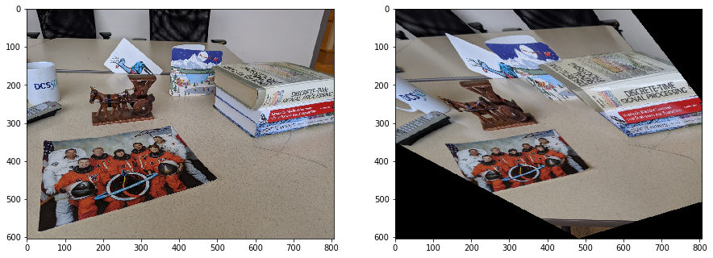

The differences between Q3.(d) are minor. They are similar.